Concept DesignSs

<https://app.creately.com/diagram/3GlHL4k27ga/view>

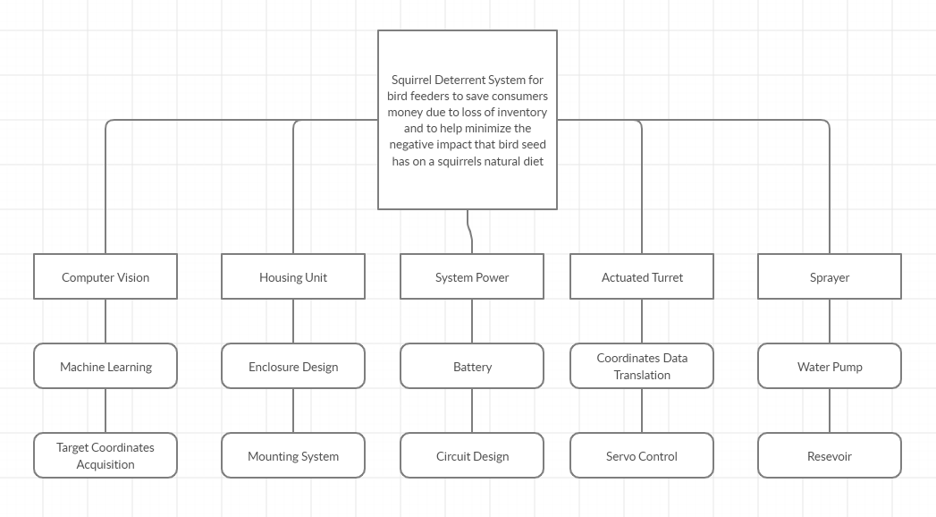

<https://app.creately.com/diagram/3LtWPpkC99S/edit>

